**Man injured in Methven logging accident**

From: http://www.newshub.co.nz/nznews/man-injured-in-methven-logging-accident-2016061315#axzz4BUDC11Xf

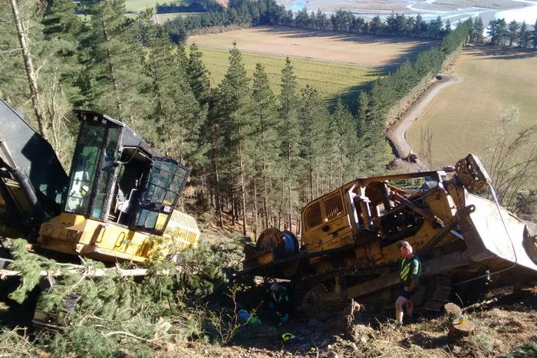

*The logging accident happened near Methven (Westpac Rescue Helicopter)*  
A 23-year-old man is in serious condition at Christchurch Hospital after getting trapped under a digger.

The Westpac Rescue Helicopter was called to the logging accident in the Methven area at 10:20am on Monday. The man was treated on the scene by paramedics and winched on-board the helicopter due to the location. He remains in hospital in a serious but stable condition, a hospital spokesperson says.

WorkSafe New Zealand is investigating the incident.

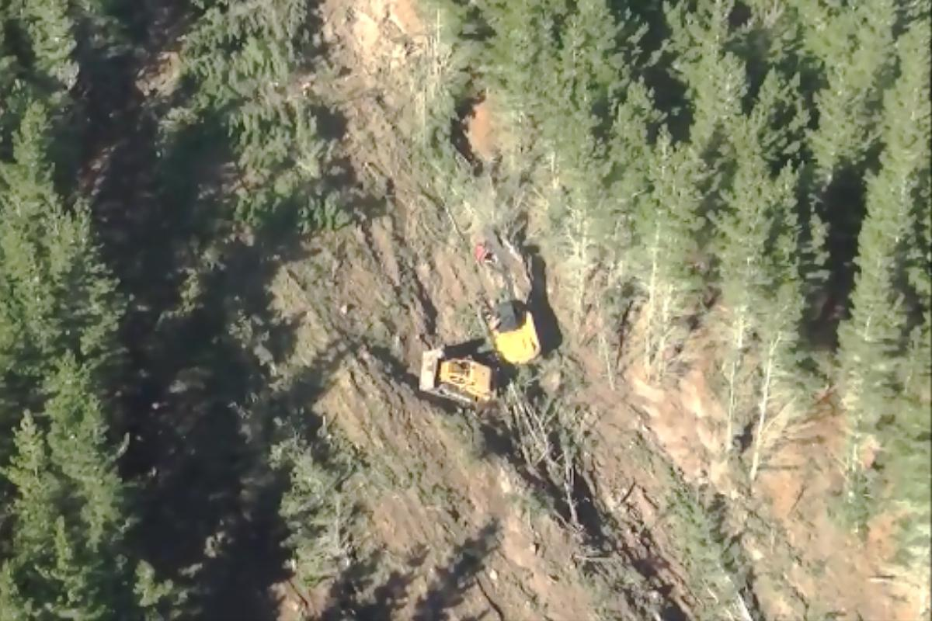  
*The man became trapped under a digger on Monday morning (Westpac Rescue Helicopter)*